NKY Healthy Smiles Program

Sign your child up for NKY Health Department’s
FREE and convenient dental services
for students at their school!

Why is our program necessary?
- Dental decay is considered the most common chronic disease in children in KY, which affects over half of children by age 8.
- Our program provides dental services to children ages 3-13.

What do we provide:
- A dental assessment- a thorough evaluation of a patient's oral health.
- A dental cleaning.
- Fluoride treatment.
- Sealants if needed- a thin, plastic coating that is applied to the chewing surfaces of back teeth to protect them from cavities.
- A completed KY dental form for kindergarten entrance if needed.
- Referral to a local dentist if further treatment is needed.



Scan the QR code to sign your child up for the NKY Healthy Smiles Program.

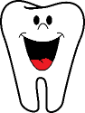
For more information:
Heather Henry
859-363-2035
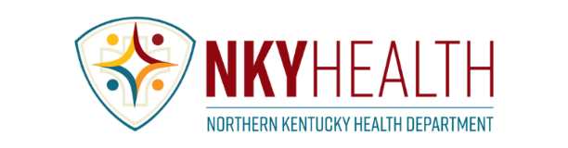
email heather.henry@nkyhealth.org

