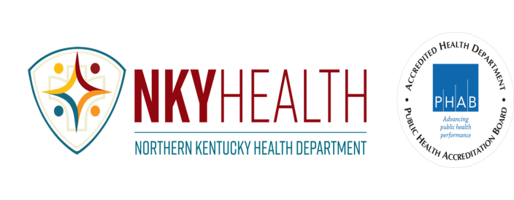
MEDICAID DENTISTS IN NORTHERN KENTUCKY
UPDATED 11/19/2024

Dental Offices that accept Medicaid
HealthPoint - 859-655-6100, all offices ACCEPTS ALL MEDICAID EXCEPT CARESOURCE; Covington and Newport location; ACCEPTS CARESOURCE.

Tri-State Dental Care- Ft. Mitchell, 859-426-9666; ALL AGES, ACCEPTS ALL MEDICAID EXCEPT UNITED HEALTHCARE.

Mortensen Family Dentistry-
Dry Ridge, 859-785-5717; ACCEPTS WELLCARE FOR 20 YR OLD AND UNDER, AND ANTHEM FOR OVER 20 YRS OLD.
Ft. Wright, 859-415-4800; ALL AGES, ACCEPTS ANTHEM, UHC, WELLCARE, AETNA, HUMANA AND PASSPORT.
Independence, 859-898-2255; ALL AGES, ACCEPTS ANTHEM AND MOLINA PASSPORT; AGES 10-20, ACCEPTS AETNA, HUMANA AND UNITED HEALTHCARE.

Dr. Wallace- Florence, 859-283-1986; PATIENTS UP TO 18 YRS OLD, ACCEPTS AETNA, WELLCARE AND HUMANA.

Friendly Dental Co.- Dry Ridge, 859-297-5536; ACCEPTS UHC FOR EMERGENCIES ONLY ON WED, THUR, AND FRI. MAY REFER TO UK OR UC FOR TREATMENT.

CHILDREN’S DENTISTS who accept Medicaid
NKY Pediatric Dentistry- Independence, 859-356-5555; PATIENTS 16 YRS OLD AND UNDER, DOESN’T ACCEPT ANTHEM OR PASSPORT.

Dr. Kees- Ft. Mitchell; 859-331-4449; PTS 9 YRS OLD AND UNDER, ACCEPTS AETNA AND WELLCARE ONLY.

Dentists for those with no coverage and in financial need; may charge based on income:
McMicken Dental Clinic; Cincinnati; 513-763-2200
UC Health Dental Center; 513-584-6650
Children’s Hospital Dental; 513-636-4641; Emergency After Hours – 513-636-4200. Have walk in hours.
Crest Smile Cincinnati; 513-352-4072
Northside Dental Clinic; 513-357-7610

Questions? Call or email Heather Henry at 859-363-2035 or heather.henry@nkyhealth.org
Northern Kentucky Health Department
8001 Veterans Memorial Drive, Florence KY 41042 | 859-341-4264 | www.nkyhealth.org
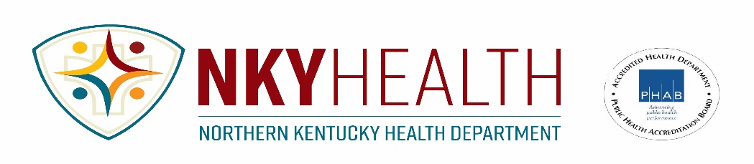

Dentistas que aceptan Medicaid en el norte de Kentucky
11/19/2024

Dentistas que ven todas las edades
HealthPoint - 859-655-6100, all offices ACCEPTS ALL MEDICAID EXCEPT CARESOURCE; Covington and Newport location; ACCEPTS CARESOURCE.

Tri-State Dental Care- Ft. Mitchell, 859-426-9666; ALL AGES, ACCEPTS ALL MEDICAID EXCEPT UNITED HEALTHCARE.

Mortensen Family Dentistry-
Dry Ridge, 859-785-5717; ACCEPTS WELLCARE FOR 20 YR OLD AND UNDER, AND ANTHEM FOR OVER 20 YRS OLD.
Ft. Wright, 859-415-4800; ALL AGES, ACCEPTS ANTHEM, UHC, WELLCARE, AETNA, HUMANA AND PASSPORT.
Independence, 859-898-2255; ALL AGES, ACCEPTS ANTHEM AND MOLINA PASSPORT; AGES 10-20, ACCEPTS AETNA, HUMANA AND UNITED HEALTHCARE.

Dr. Wallace- Florence, 859-283-1986; PATIENTS UP TO 18 YRS OLD, ACCEPTS AETNA, WELLCARE AND HUMANA.

Friendly Dental Co.- Dry Ridge, 859-297-5536; ACCEPTS UHC FOR EMERGENCIES ONLY ON WED, THUR, AND FRI. MAY REFER TO UK OR UC FOR TREATMENT.

Dentistas para niños
NKY Pediatric Dentistry- Independence, 859-356-5555; PATIENTS 16 YRS OLD AND UNDER, DOESN’T ACCEPT ANTHEM OR PASSPORT.

Dr. Kees- Ft. Mitchell; 859-331-4449; PTS 9 YRS OLD AND UNDER, ACCEPTS AETNA AND WELLCARE ONLY.

Dentistas para aquellos que no tienen seguro y necesitan financieramente
McMicken Dental Clinic; Cincinnati; 513-763-2200
UC Health Dental Center; 513-584-6650
Children’s Hospital Dental; 513-636-4641; Emergency After Hours – 513-636-4200. Have walk in hours.
Crest Smile Cincinnati; 513-352-4072
Northside Dental Clinic; 513-357-7610

Pida al traductor de la escuela de su hijo que se ponga en contacto conmigo:
Heather Henry at 859-363-2035 or heather.henry@nkyhealth.org
Northern Kentucky Health Department
8001 Veterans Memorial Drive, Florence KY 41042 | 859-341-4264 | www.nkyhealth.org

